Machine Problem 5(Python) Screenshots:

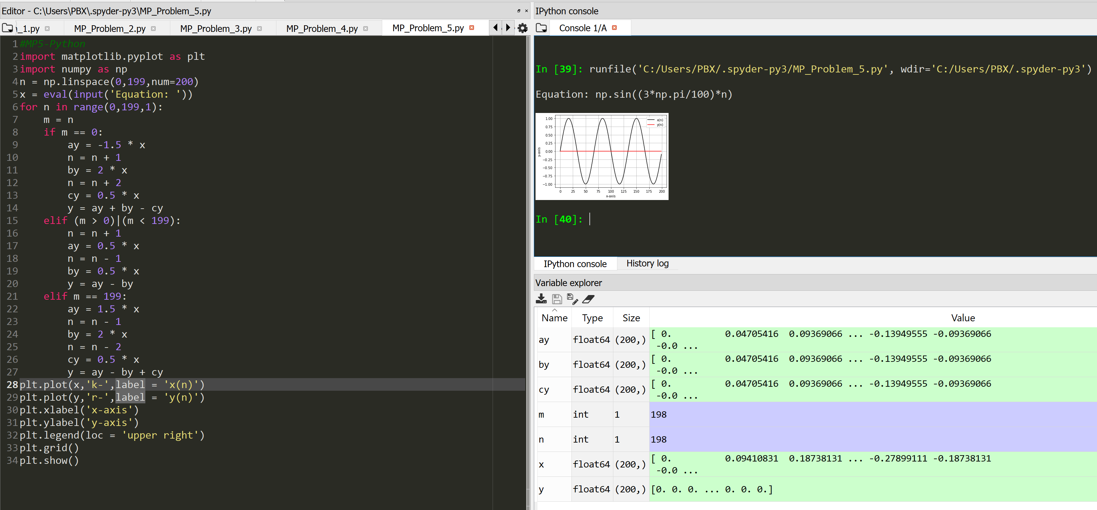

Picture Code Testing with equation: sin((3\*pi/100)\*n)

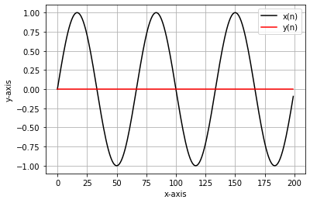

Figure The resulting graph